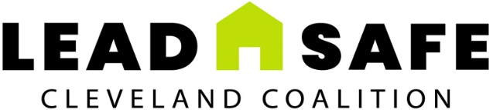
Lead Safe Cleveland Coalition
c/o Enterprise Community Partners, Inc.
Cleveland, OH
leadsafecle.org

APPLICATION FORM

Name:
Street Address 1:
Street Address 2:
City: State: Zip:
Telephone Number:
Website (if available):

Contact Person’s Name and Title:
Street Address:
Street Address 2:
City: State: Zip:
Telephone Number:
Email Address:

Contracted Roles Addressed in this Response (check all that apply)

- Lead Risk Assessor
- Lead Inspector
- Lead Abatement Contractor
- Lead Clearance Technician
- General Contractor with Renovation, Repair and Painting (RRP) Firm Certification
- RRP Certified Individual
- Related Lead Safe Workers (specify):

Do you presently work for the City of Cleveland as an employee?

Yes
No

Businesses Only
Business Tax ID #:
Business Structure (check one):

- Sole Proprietorships
- Partnerships
- Corporations
- S Corporations
- Limited Liability Company (LLC)

Business is qualified to do business in the State of Ohio as a foreign corporation.

Yes
No
Not Applicable
A. BACKGROUND AND EXPERIENCE
Instructions: Complete each question in this section.

1. Describe your area(s) of expertise:

2. How many years of experience do you have in each area of expertise?

3. How many jobs have you completed for each area of expertise in the last three years?

4. Provide details of two jobs, including a brief project description, project cost, days to completion, and client names.

5. Indicate the number of employees who will be working on the contracted projects and include their names, roles, and responsibilities.

6. Do you have internal policies that promote equal opportunity and non-discrimination?

Yes No

If yes, please describe the policies.

7. Payments are made after the completion of the project. Are you able to incumber the project costs until payment is received?

Yes No

Please explain.

B. PROJECT MANAGEMENT AND METHODOLOGY
Instructions: Complete each question in this section.

1. Describe practices and measures used to manage projects:

2. Describe how you handle scheduling:

3. What types of training and development are offered to your workers?

4. How do you approach conflict resolution?

5. How do you ensure your customers are satisfied with your services?

6. What accreditations, certifications, and licenses do you have?

7. How do you provide staff and project supervision?

C. OTHER QUESTIONS
Instructions: Complete each question in this section.

1. Some of our customers are non-English speaking. Do you or your workers speak any languages other than English? If yes, please list the additional languages.

2. Do you plan on working with any subcontractors on the contracted projects associated with this RFQ? If yes, please provide their names.

D. ENTRY-LEVEL RESPONDENTS ONLY
Instructions: Entry-level Respondents with appropriate training but limited to no experience are welcome to apply. Respondents should share below their interest in the work, previous experience, and other skills and credentials that would support the completion of the Scope of Work described in the RFQ.

#. REQUIRED ATTACHMENTS
Instructions: Check the boxes showing which attachments are included with the submission.

- Resumes of persons that would work on the project, if available
- Proof of insurance (Declaration pages only)
- Copies of appropriate licenses and certifications

Three written references from clients you have worked with in the last two years and your services were similar to those sought by this RFQ. These can be handwritten notes, typed letters, or emails. This SHOULD NOT be a list of client references.

